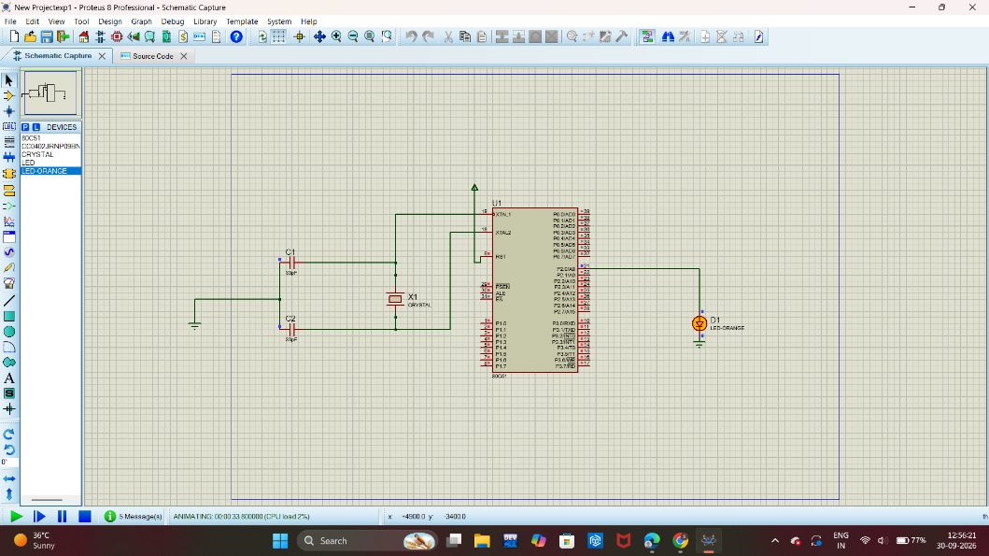
EXPERIMENT-1 BLINKING AND FLASHING OF LED USING AT89C51 MICROCONTROLLER
EXP 1a) blinking

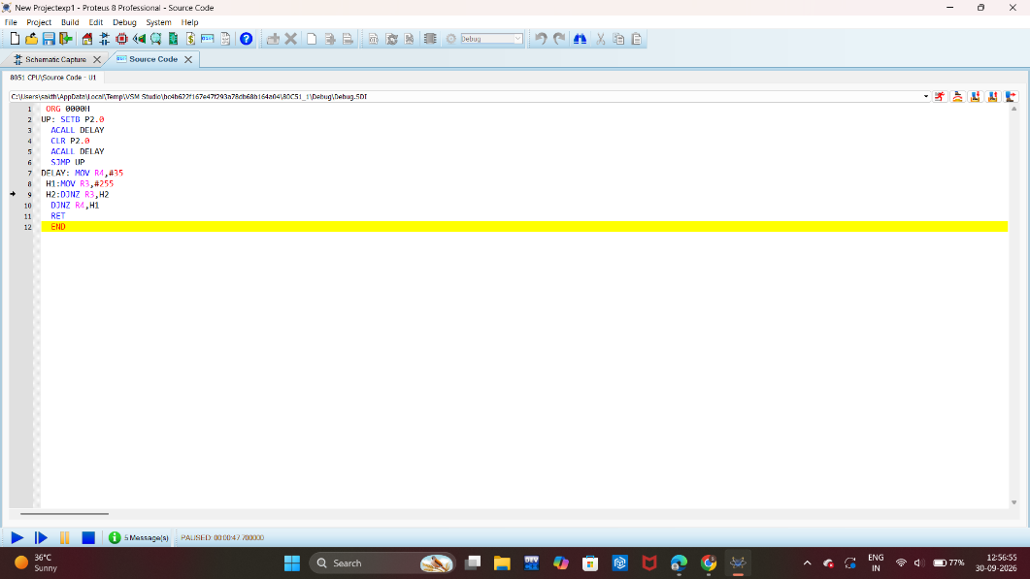

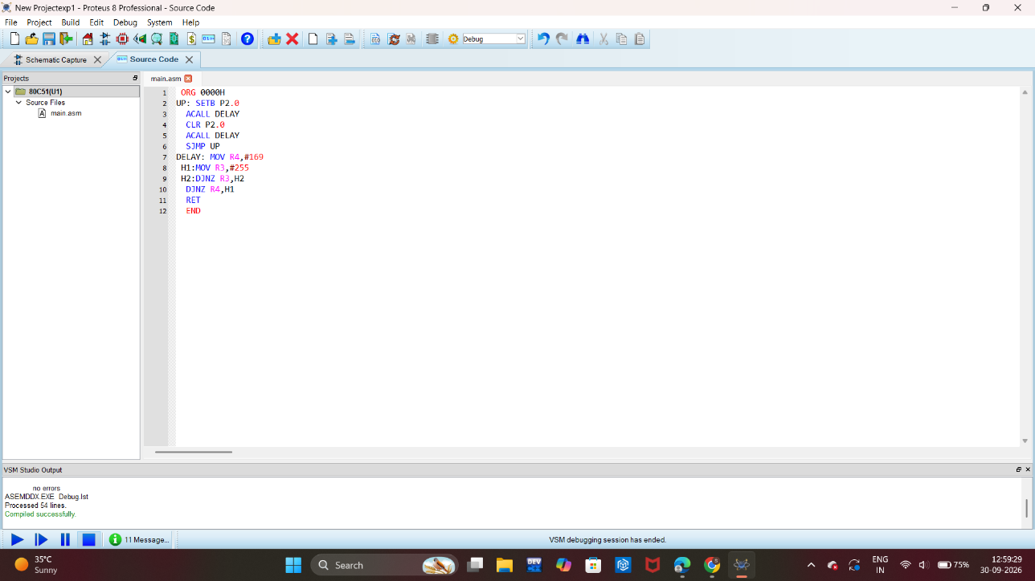
EXP 1b) flashing
